Welcome Club

May 7th 2021~ 3:30pm-4:30pm

 Character lesson of the month:

Citizenship- saying thank you

* I’m an important part of my community!

**3:30-3:35**

Introduction to Welcome Club  - (Coach Becca)

-Build friendships

-Help each other

-Discuss problems and issues with coaches and students

-Have fun!

 *Review Welcome club’s foundation for how we treat each other: Treat others the way you want to be treated.

-**Transition**- (Coach Megan) “Ok let’s have the coaches introduce themselves and what they like best about our community!”

**3:35-3:45**

 Introduction of Coaches- We will take turns sharing our name and what we like best about our community.

-**Transition**- (Coach Amy) “Now I want to introduce our lesson for today.”

Introduction of Character Lesson- “Today we are going to talk about citizenship.

-**Transition**- (Coach Colin) “Let’s get into our breakout rooms and we can start with a game! Everyone make sure you have your Welcome Club bag, pen and glue.”

**3:45-3:55**

- Coaches, start your group time by having each student introduce himself or herself and share what season they feel like today. Next, you will need to explain the rules of the game. Assistant coaches are encouraged to participate.

ICEBREAKERS  - Scavenger Hunt word game

Directions: Students will search for specific items one at a time listed below and bring them back to show the group.

Items: piece of fruit, ball, something that starts with a B, a towel, a pillow, a cup, glasses, a coin, a blanket, a backpack, a hat.

Word game: Now that each student found the items use specific items for the word game. Coaches will use paper or white board to make blank spaces for the location the scavenger hunt items would be used/found. Students will guess one letter at a time using the question as a hint. Example- Where do you take your backpack? _ _ _ _ _ _ The answer is SCHOOL. **\*Use a black marker for best zoom viewing\***

List of word game questions and answers: Where do you take your backpack? School. Where can you find your blanket? Bed. Where can you spend your coins? Store. Where do you use a ball? Park. Where do fruit grow? Farm.

**-Transition-** (coaches) “Look at all the things in your house that you use in your community. You use your coins at the store. You play with a ball at the park. You take your backpack to school. Let’s talk more about our community”.

**3:55-4:10**

 Lesson:    Saying Thank you

Coaches:

“What is our definition for citizenship? *Give students a chance to answer.* Yes! You are an important part of our community. What is a community? A community is a place where people live and work together. What are the different communities you are a part of? *Possible answers: family, apartment complex, Starr King school, Sacramento, Welcome Club, etc. Coaches share some of the communities you are a part of.* Today we are thinking about our family communities. Families are a very important part of our lives and **you** are a very important part of your family. Family communities are the most special community. What make your family community different than the other communities you have? *Give students time to answer. Possible answers: Live in the same house, take care of each other every day, eat together, keep each other safe, love each other, family were the first people you knew, family teaches you, etc.* Families grow strong when they love and help each person in the family.  We want to help you say, “I love you” and encourage your mom. This weekend is Mother’s Day. We are going to make a craft to give to our moms. What are some other ways we can say thank you to our moms?

**Transition**- “Everyone get out your craft supplies from your Welcome Club bag.”

**4:15-4:30 Craft- Mother’s Day flowers**

**Supplies:** 4 Paper cut outs from Welcome Club bag, 3 cupcake liners, pencil or pen, glue stick or tape, 3 green craft sticks.

Have students write a nice message to their mothers onto the paper pot. Next, insert one end of the green craft stick through the top cut of on the pot so that the end of the green stick in on the back of the pot. Glue or tape the stick to the back of the pot. Students will then roll the end of the petals with a pen/pencil to curl ends. Then, glue flower paper cut out onto green craft sticks to make a flower. Lastly, glue the cupcake liners to the middle of the flower. If using a glue stick craft is fragile until dry.

**\*Take time to talk about how students will help, encourage, show love and thank their mothers this weekend.**

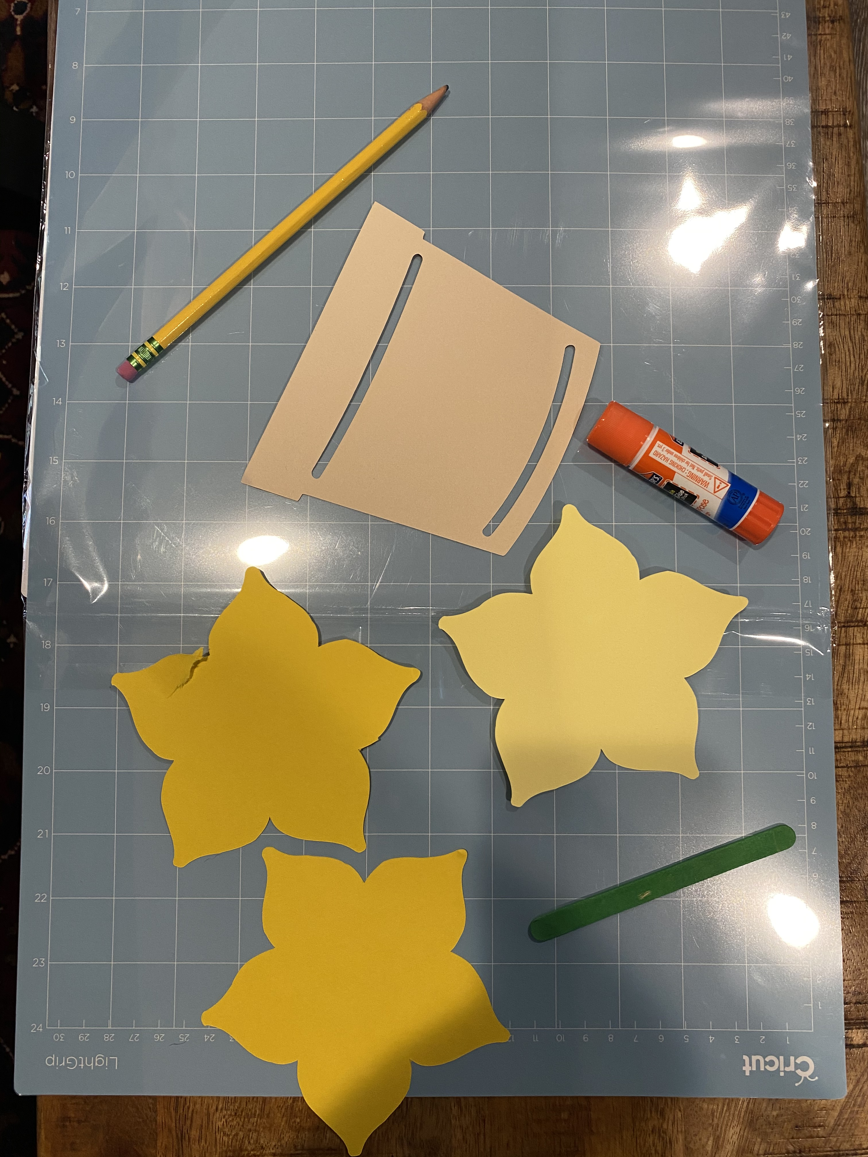

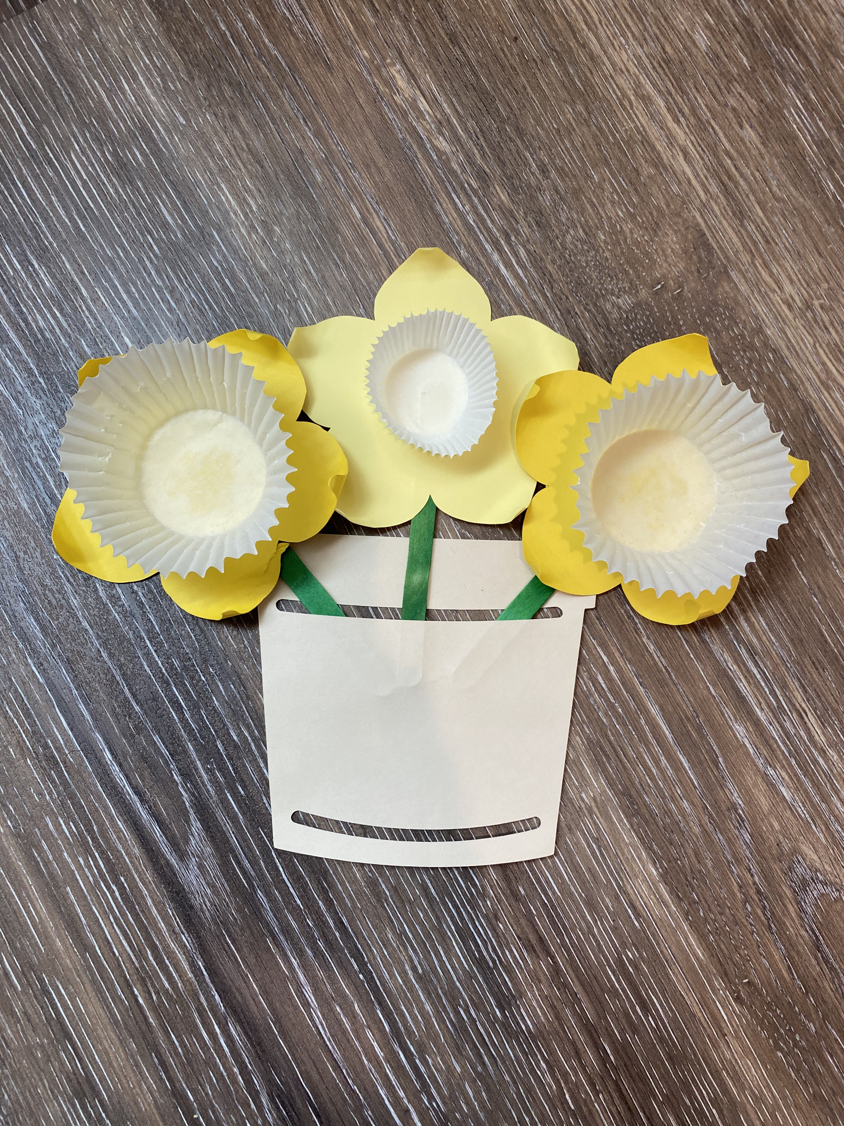

Conversation starters and fun question ideas-

1. Would you rather be a celebrity or be a doctor?
2. Would you rather design a video game or design a tall building?
3. Would you rather be a doctor for people or a veterinarian?
4. Would you rather visit space or the animals of Madagascar?
5. Would you rather be a scuba diver or an airplane pilot?
6. Would you rather live in a zoo or in an aquarium?
7. Would you rather live on a farm or in a fancy building in a city?
8. Would you rather live in Europe or Asia?
9. Would you rather be a teacher or a police officer?
10. Would you rather swim every day or dance every day?
11. Would you rather be able to speak every language on earth or communicate with aliens?
12. Would you rather be able to understand what animals are saying or have the ability to be invisible?
13. Would you rather be a superhero or an astronaut?
14. Would you rather make your dreams come true or make other people’s dreams come true?
15. Would you rather be able meet your favorite book character or meet someone famous from history?

**4:30**

 Wrap up and Goodbyes

* Updates and information-(Coach Makayla)
* Tutoring- Thursday 2:30pm  Reading pod- Monday 3:30(Coach Megan/Makayla)

**\*Coaches stay on for quick debrief**